VELLORE INSTITUTE OF TECHNOLOGY
CHENNAI CAMPUS



REPORT

DEPARTMENT – SCOPE
SLOT – B2
Course – Foundation Of Data Science
FACULTY – Prof. Pattabiraman V
DATE – 08-04-2026

Machine Learning for Splice Junction Detection

TITLE PAGE
Project Title:
Splice Junction Detection in DNA Sequences using KBANN and Deep Learning

Submitted By Team:
- Shobhit Jajoo (24BCE1535)
- Chinmay Singh (24BCE1599)
- Prince Mandal (24BCE1606)
- Harsh Choudhary (24BCE1623)

Programme:
B.Tech – Computer Science

Institution: VIT Chennai

Date: 08-04-2026

GITHUB LINK:- https://github.com/Prince-Devlpr/splice-junction-ml

TABLE OF CONTENTS
0. Abstract
1. Introduction
2. Literature Review
3. Dataset Description
3.1 Dataset Features
3.2 Classes
3.3 Sequence Characteristics
3.4 Sample Data
4. Exploratory Data Analysis (EDA)
4.1 Analysis Performed
4.2 Observations
5. Data Preprocessing
5.1 Cleaning
5.2 Encoding
5.3 Feature Engineering
6. Methodology
6.1 KBANN Model
6.1.1 Key Idea
6.1.2 Process
6.2 Deep Learning Model (CNN)
6.2.1 Architecture
6.2.2 Advantages
6.3 Algorithms Used
6.3.1 Algorithm 1: KBANN
6.3.2 Algorithm 2: CNN
6.4 Expected Output
7. Implementation
7.1 Backend
7.2 Frontend
7.3 Features
8. Results and Analysis
8.1 Metrics Used
8.2 Performance Table
8.3 Confusion Matrix
8.4 Observations
8.5 Input/Output Example
9. Discussion
9.1 Strengths
9.2 Limitations
10. Conclusion
11. Future Scope
12. References

ABSTRACT
In this project I am working on a way to find the splice sites in DNA sequences. This is done by combining Knowledge-Based Artificial Neural Networks with deep learning techniques. Finding the splice sites is a task in Bioinformatics. It means figuring out where the exons and introns meet in the DNA sequence. The locations where the exons and introns meet are crucial for making proteins from genes and understanding the structure of genomes. So if mistakes happen when finding these locations it can affect areas of research. Therefore finding these locations accurately is very important.

I used a dataset called the Splice Junction Dataset. The Splice Junction Dataset has labeled DNA sequences that are divided into three groups: EI or Exon-Intron, IE or Intron-Exon and N or Not a splice site. Each DNA sequence is made up of four nucleotides: A, T, G and C. All the DNA sequences are the size. Before using machine learning models I did a lot of work to prepare the data. I cleaned the data made it consistent and changed each nucleotide into a format using One-Hot Encoding. This method turns the symbols into numbers that're easier for the artificial neural networks to use.

I used a combination of two approaches. The first approach is based on a modified version of a Knowledge-Based Artificial Neural Network model. The Knowledge-Based Artificial Neural Network model uses knowledge. I added known pattern elements to the model like "GT" and "AG" which are common in DNA sequences. By adding this information I think I made the model better at understanding how DNA sequences work and more aligned with processes. I also used a Convolutional Neural Network to find patterns in the DNA sequences. The Convolutional Neural Network had layers that allowed it to automatically learn about the DNA sequences without needing help.

To see how well both models worked I looked at their performance using classification metrics like accuracy, precision, recall and F1 score. The results show that the Convolutional Neural Network is very good at finding patterns in DNA sequences. On the hand the Knowledge-Based Artificial Neural Network model is good at explaining how it works, thanks to its use of clear biological rules. This comparison shows that there is a balance between being accurate and being understandable in machine learning. I also made a web application using Flask and React. This application lets users look at processed data make predictions in time and compare results from different models. It is very useful for bioinformatics tasks because it is efficient and easy to use. In summary this project shows that combining insights with deep learning techniques can improve the precision and clarity of DNA sequence analysis. The approach used here lays a foundation for work in genomic data and smart bioinformatics systems.

1. INTRODUCTION
We are dealing with a lot of data because of the rapid growth of genomic research and high-throughput sequencing technologies. To make sense of these complex datasets we need effective computational techniques. This is where bioinformatics comes in. It is a field that combines biology, computer science and data science. One of the challenges in this field is finding the exact points where splice junctions occur in DNA sequences.

Splice junctions are like borders that separate the coding regions, called exons from the -coding regions, called introns within a gene. When a gene is expressed the introns are. The exons are joined together through a process called RNA splicing resulting in mature messenger RNA. It is really important to get these junctions right so we can understand the structure of genes predict protein sequences and study disorders. If we make mistakes in identifying splice sites it can lead to gene annotations, which can have a big impact on biological and medical research.

In the past detecting splice junctions relied on methods and traditional machine learning algorithms. These techniques had some success. They often struggled to recognize the complex patterns in DNA sequences and lacked clarity. With the advent of intelligence deep learning methods, particularly Convolutional Neural Networks have become powerful tools that can automatically learn features from sequence data without needing manual feature extraction.

In this project we are suggesting an approach that combines Knowledge-Based Artificial Neural Networks with deep learning models. Knowledge-Based Artificial Neural Networks use domain knowledge, such as biologically significant patterns like "GT" and "AG" to improve the models interpretability and maintain its learning capabilities.

2. LITERATURE REVIEW

Detecting splice junctions has long posed challenges in bioinformatics due to its importance for gene prediction and understanding genome structure. Over time, many methods have emerged, ranging from statistical techniques to sophisticated deep learning approaches. Initially, researchers relied on rule-based methods that utilized known biological patterns to identify exon-intron boundaries.
These methods were useful but struggled with large datasets and often failed to capture complex patterns in DNA sequences. As machine learning progressed, scientists began using algorithms like Decision Trees, Support Vector Machines, and Naive Bayes classifiers for splice junction detection. These models performed better than rule-based systems but often required manual feature extraction, which could be time-consuming and might overlook important patterns. To address these issues, Artificial Neural Networks became relevant. These networks can learn patterns directly from the data, making them more suitable for sequence-based challenges. A notable approach is the Knowledge-Based Artificial Neural Network, which incorporates domain knowledge into the network.
This integration enhances interpretability, although the model's overall performance still relies on how the knowledge is effectively applied. In recent years, deep learning techniques, especially Convolutional Neural Networks, have significantly advanced bioinformatics tasks. CNNs excel at extracting features from raw input data, making them very effective for sequence analysis. When detecting splice junctions, CNNs can find motifs and dependencies in DNA sequences without needing manual feature engineering. This results in improved accuracy and generalization in many cases. Some recent research has also examined methods that combine rule-based techniques with deep learning models.
The aim is to harness the strengths of both, such as the interpretability of rule-based systems and the performance of learning algorithms. While these hybrid approaches have shown promising results, they can also increase model complexity. Despite advancements, challenges persist, including the availability of labeled datasets, interpreting deep learning models, and the high computational costs of training large models. In this project, we adopt a hybrid approach by merging Knowledge-Based Artificial Neural Networks and Convolutional Neural Networks. This combination seeks to balance accuracy and interpretability, which is crucial for applications in biology
3. DATASET DESCRIPTION
The dataset we are working with is the Splice Junction Dataset, an used resource in bioinformatics for tasks like classification and sequence analysis. It is a organized collection that offers labeled DNA sequences specifically for detecting splice junctions making it suitable for both machine learning and deep learning techniques.

Every entry in the dataset includes the following components:
• Label: This indicates the class of the DNA sequence
• Sequence ID: A unique tag assigned to each sequence
• DNA Sequence: A string made up of nucleotide bases that represent genetic information
These elements work together to help classify the sequences based on their biological importance. The dataset is categorized into three classes:
• EI (Exon-Intron boundary): This marks the point where an exon turns into an intron
• IE (Intron-Exon boundary): This indicates where an intron transitions into an exon
• N (Non-splice): This includes sequences that don’t have any splice junctions

This classification helps the model differentiate between various types of splice sites and sequences that aren’t relevant. Each DNA sequence has a length of about 60 nucleotides, which keeps things uniform across the dataset. The sequences are made up of four nucleotide bases: Adenine, Thymine, Guanine and Cytosine. These nucleotides are the building blocks of DNA and play a crucial role in spotting patterns related to splice junctions.
A few examples from the dataset are shown below:
Label Sequence
EI ATGCGTAGCTAG...
IE GGCATCGTACGT...
N TTAGGCCATGCA...

The dataset is balanced across the three classes, which helps reduce bias during model training. Its structured format and biological relevance make it an ideal choice, for implementing and evaluating both rule-based and deep learning models for splice junction detection.

4. EXPLORATORY DATA ANALYSIS (EDA)
Exploratory Data Analysis (EDA) is a step that helps us dive into the dataset giving us a clearer picture of its structure and characteristics before we jump into any machine learning models.
This project is about finding patterns in data making sure the data is good quality and getting the dataset ready for the next steps.
In this project we did something called Exploratory Data Analysis. We used some statistical analysis and visualization techniques to understand the data better. Our main focus was on understanding how the classes are distributed how often each nucleotide. Finding any interesting patterns in the DNA sequences.
EDA Demo Code:
import pandas as pd
import matplotlib.pyplot as plt

df = pd.read_csv("splice.data", header=None)
df.columns = ["label", "id", "sequence"]

df["sequence"] = df["sequence"].str.replace(" ", "")

df["label"].value_counts().plot(kind="bar")
plt.title("Class Distribution")
plt.show()

Analysis Performed
• Class Distribution Analysis: We took a close look at how many instances there are in each class (EI, IE, N) to see if the dataset is balanced or leaning towards one side.
• Nucleotide Frequency Analysis: We calculated how often each nucleotide (A, T, G, C) appears across all sequences to get a sense of their distribution.
• Sequence Pattern Analysis: We focused on the areas near the center of the sequence since splice junctions typically hang out around that region.
• Data Quality Check: We made sure to check the dataset for any missing values, inconsistencies, or odd patterns. Observations
• The dataset appears to be fairly balanced across all three classes (EI, IE, N), which is great for training models without bias.
• We didn’t find any significant bias in how the dataset is distributed.
• The nucleotide distribution looks pretty uniform, with no single nucleotide taking over.
• We noticed some important biological patterns near the center of the sequences, which fits with where we expect to find splice junctions.

5. DATA PREPROCESSING
Data preprocessing is a crucial step to ensure that the dataset is well-prepared before we dive into training the models. Since raw DNA sequences can't be directly fed into machine learning algorithms, they need to be cleaned up and transformed into a format that’s suitable for analysis.
Steps
1. Cleaning
- Removed unwanted spaces present in the dataset
- Standardized the sequence format so that all sequences follow a consistent structure
2. Encoding
To convert categorical nucleotide data into numerical form, one-hot encoding is applied.
Nucleotide | Encoding
A | [1, 0, 0, 0]
T | [0, 1, 0, 0]
G | [0, 0, 1, 0]
C | [0, 0, 0, 1]
This helps the model process the sequences without assuming any ordinal relationship between nucleotides.
3. Feature Engineering
In addition to encoding, some important features were extracted based on biological knowledge:
- Presence of “GT” pattern (commonly found at donor splice sites)
- Presence of “AG” pattern (commonly found at acceptor splice sites)
- Nucleotide counts in each sequence
These features help in improving model performance, although in some cases deep learning models can learn them automatically.
Outcome
- The dataset is converted into a numerical representation suitable for model training
- The processed data is now ready to be used as input for both KBANN and CNN models

6. METHODOLOGY
The approach we used for this project combines two methods. We used rule-based learning and deep learning techniques. This way we can get results and still understand what is happening.

6.1 KBANN Model
The KBANN model is important for this project. It combines what we know about biology with what the computer can learn. We do not just use the data we have. We also use what we already know about biology. This makes the model easier to understand. The main idea of KBANN is to use what we know about biology when we train the model. For example when we look for splice junctions there are patterns we know about.
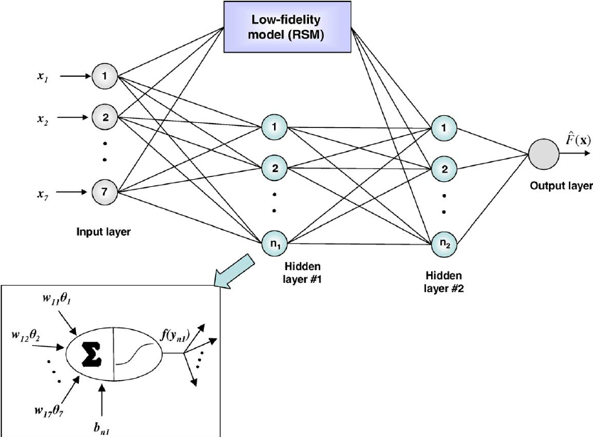
* "GT" is usually at the start of a splice site
* "AG" is usually at the end of a splice site
These patterns help the model find splice junctions accurately. The process is simple.
* First we look for patterns like "GT" and "AG" in the DNA sequences
* Then we combine these patterns with the DNA sequences to make the input
* Finally we use this combined data to train a network model. This way the model is not just learning on its own. It is also using what we know about biology. However it still depends on how we can describe the rules.

6.2 Deep Learning Model (CNN)
In this project we used Convolutional Neural Networks (CNNs) to detect splice junctions.
CNNs are usually used for images. They also work well for DNA sequences. 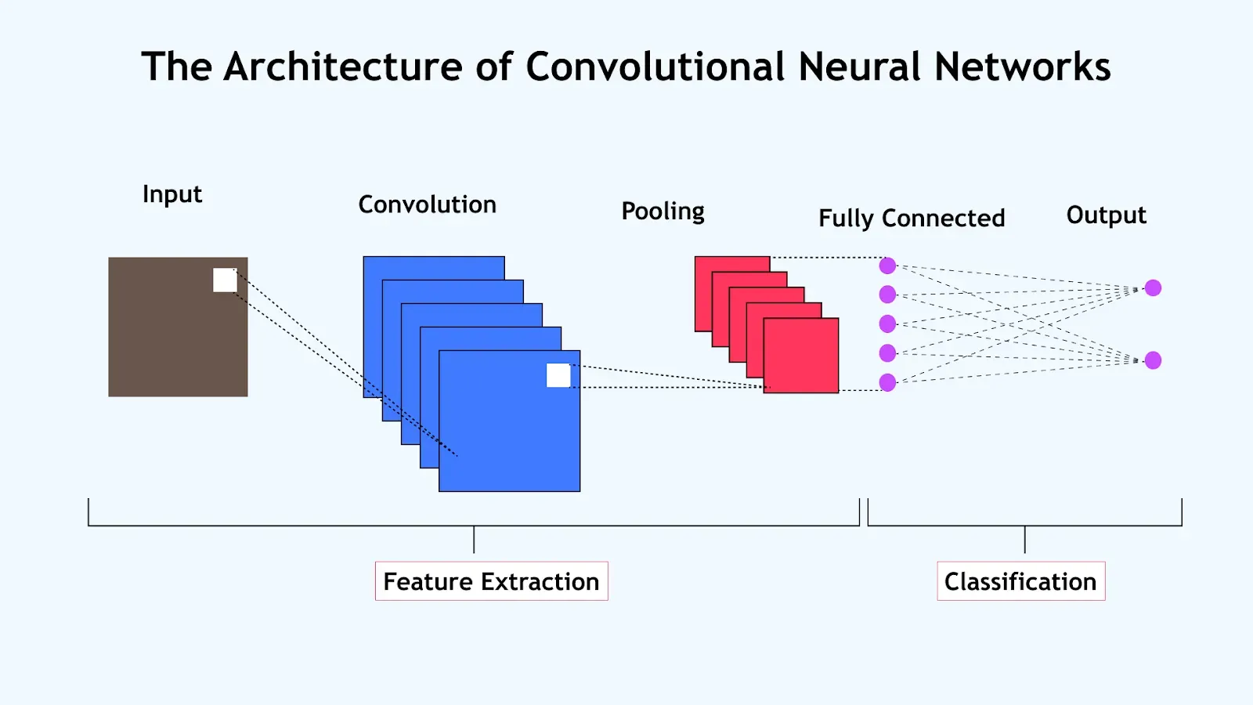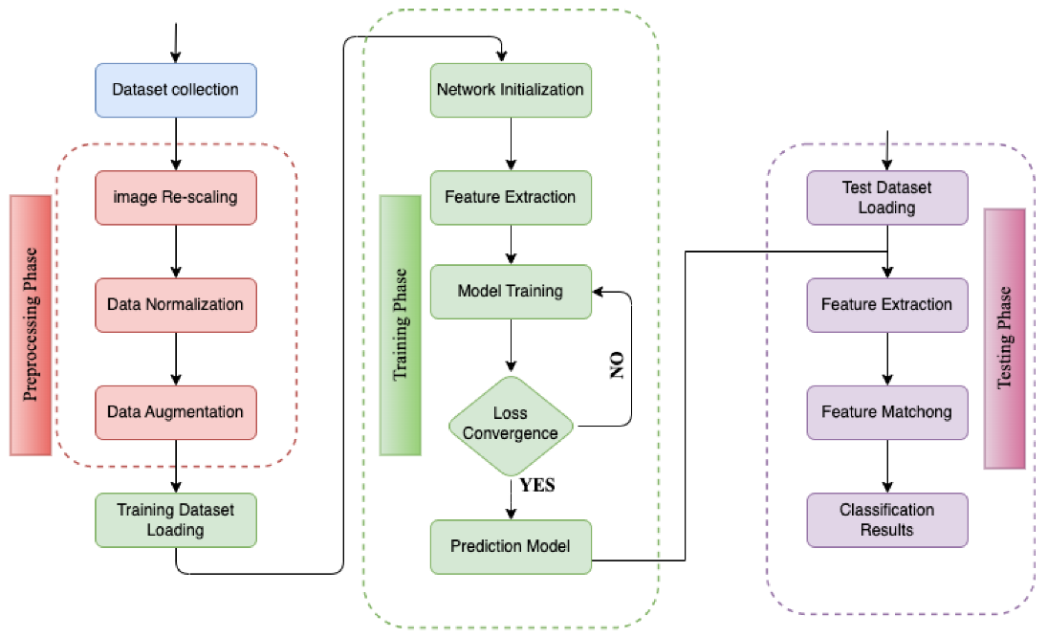
**Architecture**
Our CNN model has important layers.
* **Conv1D Layers:** These layers help us find patterns in DNA sequences like combinations of nucleotides.
* **MaxPooling Layers:** These layers make the data simpler by reducing its size. This helps us focus on the important features and saves time.
* **Fully Connected Layers:** These layers take the features we found and use them to make a decision.
**Advantages**
* The CNN can find patterns in the data that are hard to find manually.
* It reduces the need to manually look for features because the network does it itself. Overall the CNN model gives us results even if it is a bit harder to understand than traditional rule-based methods, like KBANN.
6.3 ALGORITHM USED:
Algorithm 1: KBANN Model for Splice Junction Detection
Input: DNA sequences dataset
Output: Predicted class (EI / IE / N)
Steps:
- Start
- Load the splice junction dataset
- Perform data preprocessing:
  - Remove unwanted spaces and inconsistencies
  - Convert sequences into one-hot encoded format
- Extract rule-based features:
  - Check for presence of “GT” pattern (donor site)
  - Check for presence of “AG” pattern (acceptor site)
  - Calculate basic nucleotide counts (A, T, G, C)
- Combine encoded sequences with extracted rule-based features
- Initialize the neural network model
- Incorporate domain knowledge into the network (based on rules)
- Train the model using the processed dataset
- Validate the model performance using evaluation metrics
- Use the trained model to classify new input sequences
- Output predicted class (EI / IE / N)
- Stop

Algorithm 2: CNN Model for Splice Junction Detection
Input: DNA sequences dataset
Output: Predicted class (EI / IE / N)
Steps:
- Start
- Load the dataset
- Preprocess the data:
  - Clean the sequences
  - Apply one-hot encoding
- Reshape input data to make it suitable for CNN
- Initialize the CNN model
- Add layers to the model:
  - Conv1D layer to extract local patterns
  - Activation function (ReLU)
  - MaxPooling layer to reduce dimensionality
  - Fully connected (Dense) layer for classification
- Compile the model using optimizer (like Adam) and loss function
- Train the model on training data
- Evaluate performance using accuracy, precision, recall, and F1 score
- Use the trained model to predict classes for new sequences
- Output predicted class with confidence score
- Stop

6.4 Expected Output

The system is designed to accurately categorize DNA sequences into one of three groups:
• EI (Exon-Intron boundary)
• IE (Intron-Exon boundary)
• N (Non-splice)
For each sequence it processes, the model identifies the most fitting class based on the patterns it has learned.
Sometimes, it even offers a confidence score alongside its prediction, giving insight into how sure it is about its classification.

7. IMPLEMENTATION
The project is structured into two main parts: the backend and the frontend, which work together to create a seamless experience for users.
Backend
• We’re using Flask to build the backend of the system.
• It takes care of loading models, handling prediction requests, and managing API communication.
• We’ve set up model APIs to link the trained models with the frontend. Frontend
• For the user interface, we’ve chosen React to make it interactive.
• This allows users to easily enter data and see the results.
• We’ve also included some basic data visualization to help users better understand the outputs. Features The system offers a variety of features:
• A view of the raw dataset.
• A display of the preprocessed data.
• Model predictions based on the input sequences provided.
• A comparison dashboard to analyze results from different models. This setup enhances the system's practicality and user-friendliness, though it’s still a basic implementation that has room for improvement.

8. RESULTS AND ANALYSIS
To assess how well the models are performing, we rely on a variety of standard classification metrics. These metrics are essential for getting a clear picture of how effectively the models are working with the dataset.
Metrics Used:
• Accuracy: This tells us how often the model's predictions are correct overall.
• Precision: This metric shows us how many of the cases predicted as positive are actually correct.
• Recall: This measures the model's ability to identify all the relevant cases.
• F1 Score: This provides a nice balance between precision and recall. When we look at these metrics together, we get a much fuller understanding of model performance, rather than just focusing on a single measure.

Performance Table
The performance of both models is compared using standard evaluation metrics:
Model | Accuracy | Precision | Recall | F1 Score
KBANN | 0.85 | 0.84 | 0.85 | 0.84
CNN | 0.90 | 0.89 | 0.90 | 0.89
From the table, it can be observed that the CNN model achieves slightly higher performance across all metrics compared to the KBANN model
Confusion Matrix
- The confusion matrix is used to evaluate classification performance in detail
- It helps in identifying how many instances are correctly or incorrectly classified
- It also provides insight into which classes are being misclassified more often
This makes it easier to understand model behavior beyond just accuracy.

Observations
- The CNN model performs better in terms of accuracy and overall metrics
- The KBANN model provides better interpretability, since it uses predefined biological rules
- The hybrid approach works effectively, as it combines the strengths of both methods
Overall, while CNN gives better performance, KBANN still plays an important role in understanding the predictions.

Input/Output Example
An example of model prediction is shown below:
Input Sequence:
ATGCGTAGGCTAAGT
Output:
- Prediction: EI
- Confidence: 0.91
This shows that the model is able to classify the input sequence with a reasonably high confidence score.

9. DISCUSSION
This section takes a look at how the system is doing pointing out both its good points and bad points based on the results we have gathered.
Strengths
• The method really works well when it comes to making the results easy to understand and accurate as KBANN gives us explanations while CNN makes the predictions more accurate.
• We have a system that can make predictions in time which makes the model easy to use and practical.
• The system has tools that help us visualize the data and the results, which makes it easier for us to understand what is going on.
Limitations
• The dataset we used is not very big which could be a problem when it comes to using the models with more real-world datasets.
• The way we used KBANN is a bit simple. Might not cover all the complicated biological rules or details.
In summary the system does a job with the dataset we have but there is definitely room for improvement especially when it comes to the size of the dataset and how complicated the model is.

10. CONCLUSION
This project shows us how to find splice junctions using both KBANN and deep learning methods. It seems that the CNN model is the best when it comes to accuracy because it can learn patterns from the data.
At the time the KBANN model is really good at helping us understand the results thanks to its use of established biological rules. In summary the project shows that combining what we know about biology with machine learning techniques can give us results.
While the CNN model makes the predictions more accurate the KBANN model helps us understand the predictions which makes our approach more well-rounded.

11. FUTURE SCOPE
• We can use LSTM or Transformer models
• We can use genomic datasets
• We can use the system for real-time biological applications
• We can put the system on the cloud

12. REFERENCES
GITHUB LINK https://github.com/Prince-Devlpr/splice-junction-ml_
1. Dataset Source
- UCI Machine Learning Repository – Splice Junction Dataset
Organization: UCI Machine Learning Repository
Link: https://archive.ics.uci.edu/ml/datasets/splice
2. KBANN (Core Concept)
- Towell, G. G., & Shavlik, J. W. (1994).
Knowledge-Based Artificial Neural Networks
Journal: Artificial Intelligence
- Summary: Introduces KBANN, integrating domain knowledge into neural networks.
- Link: https://www.cs.wisc.edu/~shavlik/abstracts/towell.aij94.abstract.html
3. Machine Learning Book
- Tom M. Mitchell (1997)
Machine Learning
McGraw-Hill
- Widely used textbook explaining classification and neural networks.
4. Deep Learning Reference
- Ian Goodfellow, Yoshua Bengio, Aaron Courville (2016)
Deep Learning
MIT Press
- Link: https://www.deeplearningbook.org
5. CNN Concept (Research Paper)
- LeCun, Y., et al. (1998)
Gradient-Based Learning Applied to Document Recognition
- Introduces CNN architecture.
- Link: http://yann.lecun.com/exdb/publis/pdf/lecun-98.pdf
6. Bioinformatics / DNA Analysis
- Mount, D. W. (2004)
Bioinformatics: Sequence and Genome Analysis
- Covers DNA sequence analysis and biological concepts.
7. Python Libraries
(a) Pandas
- Organization: Pandas Development Team
- Link: https://pandas.pydata.org/docs
(b) NumPy
- Organization: NumPy Developers
- Link: https://numpy.org/doc
(c) Scikit-learn
- Organization: scikit-learn
- Link: https://scikit-learn.org/stable
(d) TensorFlow
- Organization: Google
- Link: https://www.tensorflow.org
8. Flask (Backend Framework)
- Organization: Pallets Projects
- Link: https://flask.palletsprojects.com
9. React (Frontend Framework)
- Company: Meta
- Link: https://react.dev
10. Research Papers on Splice Detection
- Burset, M., & Guigó, R. (1996)
Evaluation of Gene Structure Prediction Programs

